Project Design Phase-II
Data Flow Diagram & User Stories

Date | 31 January 2025
Team ID
Project Name | Visualizing  Housing Market Analysis:An Analysis of Sale Prices and  Features using Tableau
Maximum Marks | 4 Marks
Data Flow Diagrams:
The Data Flow Diagram (DFD) represents the flow of housing data within the system. Housing datasets containing sale prices and property features are collected from data sources. The data is cleaned, transformed, and prepared for analysis.
Tableau processes the data to generate charts, graphs, and interactive dashboards. Users interact with the dashboard using filters and visualization tools.
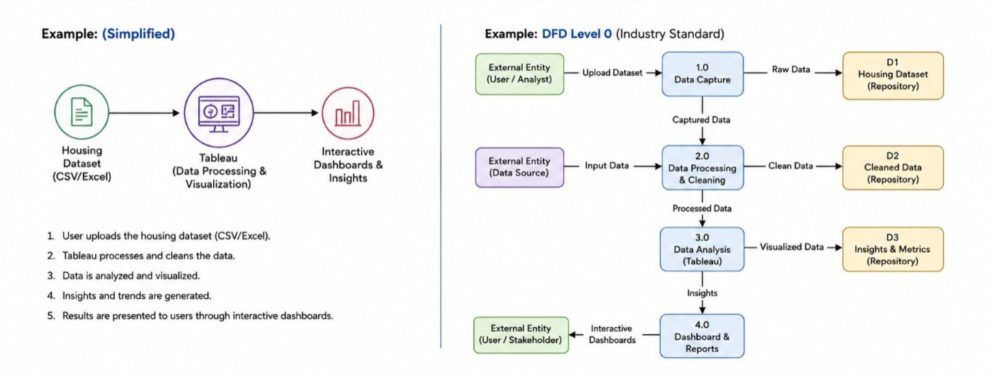
The final output provides meaningful insights into housing market trends and sale price patterns.

User Stories
Use the below template to list all the user stories for the product.

User type | Functional  Requirement (Epic) | User  Story Number | User  Story / Task | Acceptance  Criteria | Priority | Release
User (Home Buyer/ Investor) | Data Upload | USN 1 | As a user,I can upload housing  datasets in CSV or Excel format. | Dataset is successfully uploaded  and displayed in Tableau. | High | Sprint-1
User (Home Buyer/ Investor) | Data Preprocessing | USN 2 | As a user, I can view cleaned and  transformed housing data. | Missing values and incorrect data  are handled properly. | High | Sprint-1
User (Home Buyer/ Investor) | Sale Price Analysis | USN 3 | As a user, I can analyze the  distribution of house sale prices. | Sale price charts and summaries  are generated successfully. | High | Sprint-1
User (Home Buyer/ Investor) | Feature Analysis | USN 4 | As a user, I can compare  property features such as area, bedrooms, and location with sale prices. | Interactive visualizations are  displayed correctly. | High | Sprint-1
User (Home Buyer/ Investor) | Interactive  Dashboard | USN 5 | As a user, I can interact with  dashboards using filters and parameters. | Users can apply filters and view  updated insights instantly. | High | Sprint-2
User (Home Buyer/ Investor) | Trend Analy sis | USN 6 | As a user, I can identify housing  market trends and patterns. | Market trends are visualized  through charts and graphs. | Medium | Sprint-2
Real Estate Analyst | Correlation  Analysis | USN 7 | As an analyst, I can view  correlations between housing features and sale prices. | Correlation heatmaps and  analytical reports are generated. | Medium | Sprint-2
Administrator | Dashboard M  anagement | USN 8 | As an administrator, I can  manage and update dashboards and datasets. | Dashboards and datasets can be  modified successfully. | Low | Sprint-3
Administrator | Report Gene ration | USN 9 | As an administrator, I can  generate reports from housing market analysis. | Reports are exported successfully  in required formats. | Medium | Sprint-3

